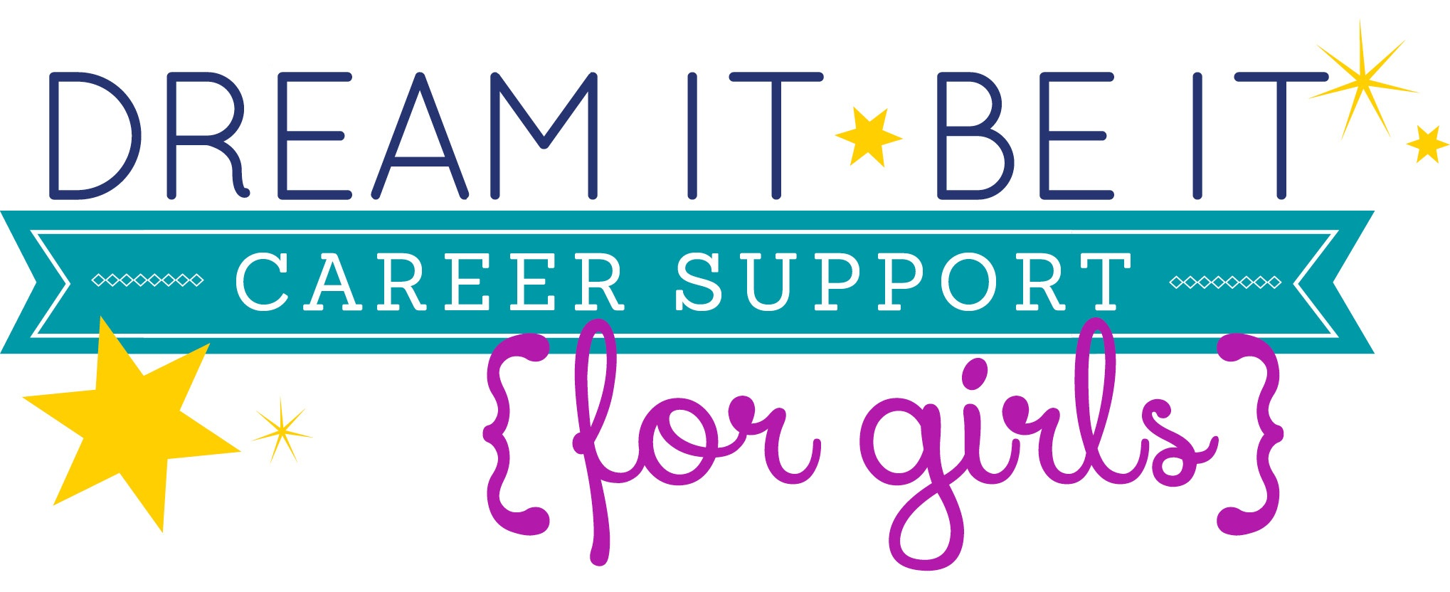Student Application
Please answer each of the following questions to help us assess your fit for this year's Dream It, Be It program. Your information will not be shared with anyone and will be kept private unless necessary for program participation (ex. sharing contact and background information with a prospective mentor).
Please apply if you will be able to attend the workshop on:
Saturday, February 25 [9-4] for 7th & 8th graders or
Saturday, March 11 [9-4] for 9th & 10th graders
Workshop participants are also eligible for mentorship, volunteering & a celebration lunch.
Your information will not be shared with anyone and will be kept private unless necessary for program participation (ex. sharing information with a prospective mentor).

Once your application is completed, you may be:
- Selected for participation in the workshop, volunteer opportunity, mentoring & celebration lunch
- Notified of wait list status (if first 15 appropriate applicants are unable to participate, wait list applicants will be notified)
- Notified that you do not meet requirements for participation (i.e. outside of target population or are unable to attend specific event dates)

On behalf of Soroptimist International of Maui, mahalo nui loa for your interest!

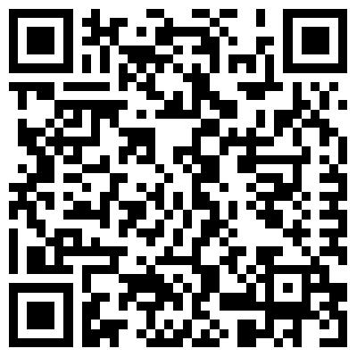
Once we have your application we can communicate via website, phone or email regarding additional information or event updates. Applications will be accepted via website or paper. Please return paper application to:

Soroptimist International of Maui
P.O. Box 1514
Kahului, HI 96733

For more information go to: SIMaui.org
For questions please contact soroptimistsofmaui@gmail.com
Basic Information:
- Full Name [first, middle, last]: ____________________________________
- Birthdate [day, month, year]: ____________________________________
- Mailing address: ____________________________________

- 10 digit phone number: ____________________________________

- Email: ____________________________________

- School or Home school you attend ______________________________

- Current grade level 7th 8th 9th 10th Other

- Will you be able to attend the workshop on Saturday February 25, 2017 if you are a 7th or 8th grader and on March 11th if you are a 9th or 10th grader?
YES NO

- What are you interested in participating in? **Please note that workshop attendance is mandatory to participate in mentoring and the celebration lunch.
[check all that apply]
The workshop
Volunteering
Mentoring
Celebration lunch

- Please rank workshop topics in order of interest 1 = most interested, 6 = least interested.
_____ Balancing Stress _____ Identity Art Project
_____ Creating Goals _____ Self Defense
_____ Exploring Careers _____ Putting Dreams Into Action

- Parent/guardian name: _____________________________________________
Parent/guardian phone # if different from applicant: _________________________
Parent/guardian email if different from applicant: ______________________

- How did you hear of the Dream it, Be it [DIBI] project?

Baseline Survey:
*Please answer as honestly as possible & Check 1 box per question

- How interested are you in attending higher education after high school?
 0% - Not at all
 25% - A little
50% - Moderately
75% - Quite a bit
 100% - Completely

- How likely are you to attend higher education after high school?
 0% - Not at all
 25% - It could happen
50% - Could go either way
75% - Quite likely
 100% - For sure

- What kind of support system (family or adult friends/mentors) do you have?
 0% - None
 25% - One to a few
50% - I could have more
75% - I'm pretty well supported
 100% - I'm completely supported

- How would you rate your self-esteem or how you think about yourself?
 0% - Completely negative
 25% - Not very many nice things to say
50% - I'm pretty average I think
75% - I'm pretty confident
 100% - I'm a shooting star

- How would you rate your ability to keep yourself safe and healthy?
 0% - Huh?
 25% - I know a little
50% - I'm pretty average I think
75% - I'm pretty confident
 100% - I'm a shooting star

- Did your parents attend and/or graduate college?

- What would you say were your biggest challenges, personally, academically, socially, economically, etc. to attending higher education post high school or having career success?

- What resources do you have and who helps you with the challenges you just described?

- What skills do you believe you need to be successful today and in the future? What are you hoping to get or learn from Dream It, Be It participation?

- What are you goals for or beyond high school? What career path are you considering or dream about? What other interests do you have?

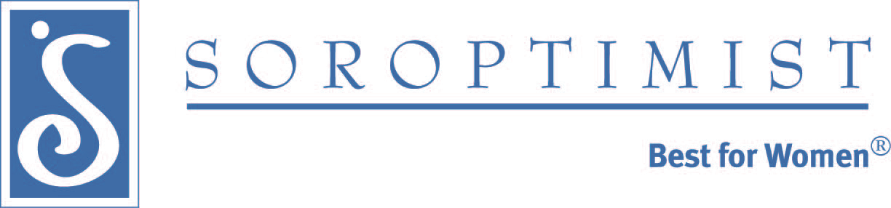
- What are you most looking for in a mentor match?

